# High disk usage alert of Pronto

1.check the monitoring [dashboard](https://console.sherlock.io/d/QVNizhaMk/dashboard-for-customers-v2?orgId=1&var-namespace=pronto&var-escluster=esadsquality-slc&var-name=All) to confirm current disk usage.

Disk usage of all data nodes.



Disk usage of three data nodes.

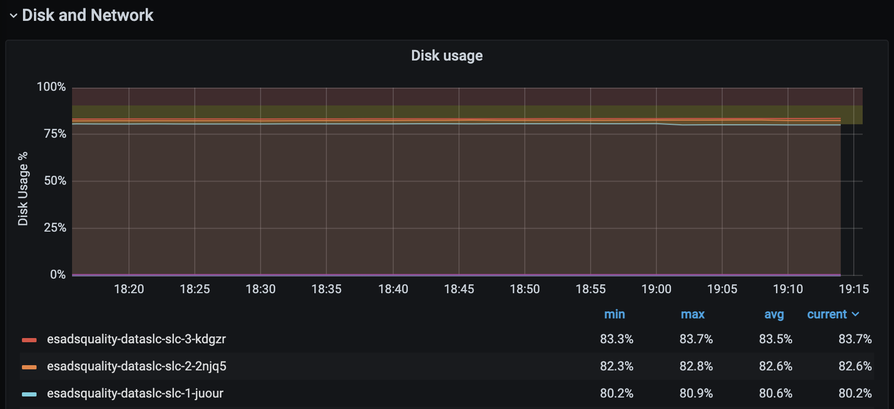

2. check if there is any index use large disk. come to [Kibana](https://esadsquality-kibanaslc.vip.ebay.com/app/kibana#/dev_tools/console) and switch to Dev Tools. and run the query: **GET _cat/indices/*?s=store.size&v=true**

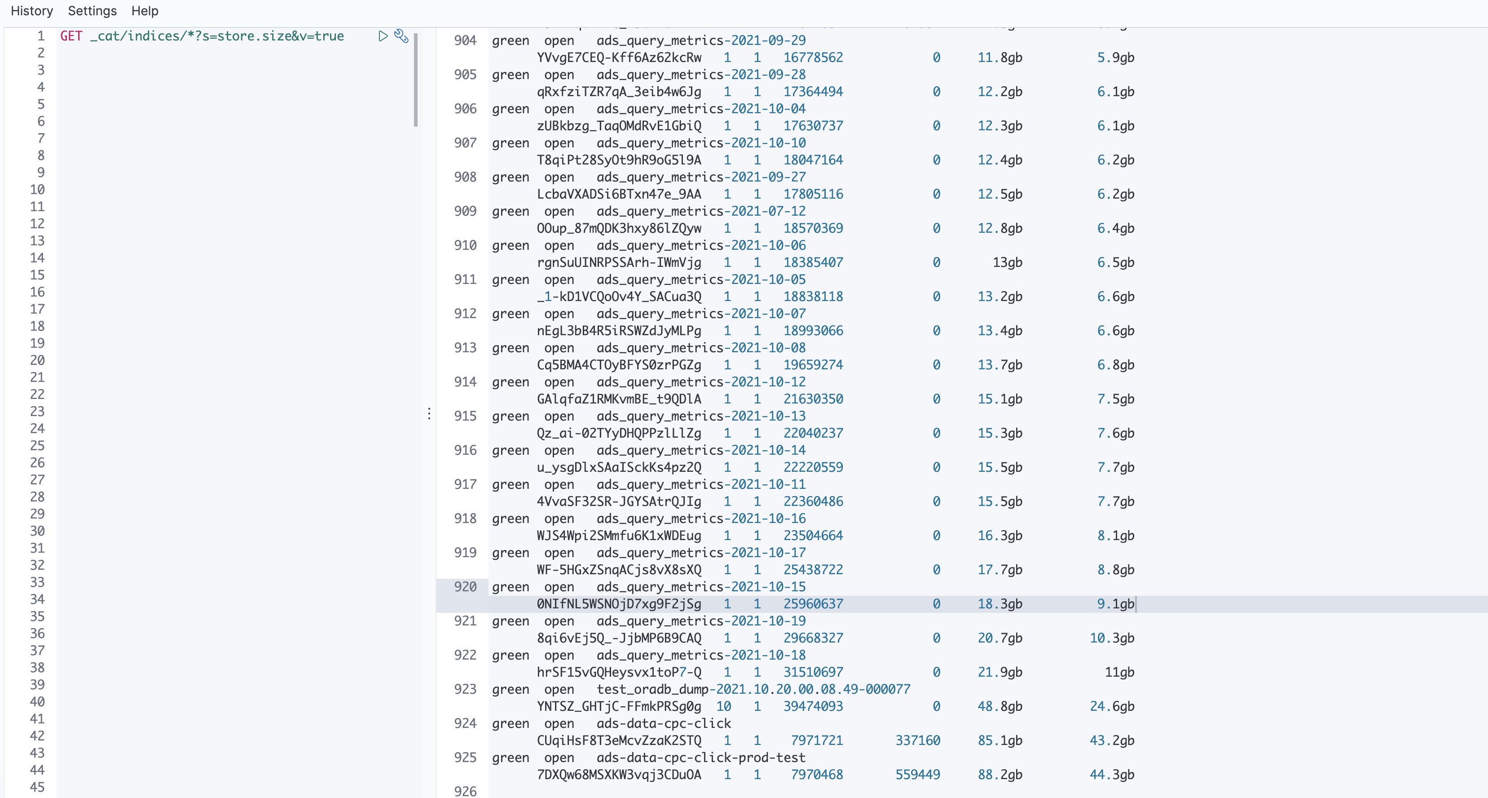

3. from the above picture.

* these two index **ads-data-cpc-click, ads-data-cpc-click-prod-test** use large disk, you can contact Wu, Chaofan to check if some of the data can be deleted
* **ads_query_metrics-\*** is used by reporting service, you can contact Wu, Marshall to check if some of the data can be deleted
* **test_oradb_dump-\***, you can contact Zhou, Chen to check if some of the data can be deleted

4.apply for larger disk. contact: Tang, Huayi or Liu, Pavel